**Project Name:** Analysis Of Football Transfer Market Network

**Github Link:** https://github.com/projectsforstudents2022/Analysis_Of_Football_Transfer_Market_Network.git

**Why was this project created?**

European football doesn't use a drafting system that aims to distribute skilled players among the teams fairly, which sets it apart from many American professional sports disciplines. In European football, players are workers of their clubs and are free to switch teams prior to the end of their contract as long as the prospective new club is prepared to compensate the old club. Football teams experienced financial hardship as a result of the pandemic and its attendant limitations, which increased their risk of bankruptcy and generally resulted in a decline in accrued transfer fees.

**What problem is it solving?**

The purpose of this research is to determine whether the structural characteristics of the transfer network exhibit any behavior that is connected to variations in the overall transfer volume or if the structure of the market is independent of the volume.

**Entire explanation of project**

* **PROPOSED APPROACH**

The graph G(V,E) of a network consists of a set of vertices V and a set of edges E that link the vertices' components. The clubs are the vertices, and the transfers between them are the edges, as shown mathematically by an adjacency matrix A. Loans, for example, are not taken into account as genuine edges between two clubs; only long-term transfers with a nonzero cost are, for two reasons: First, the value of an edge between two clubs is determined by the amount of money exchanged; as a result, transfers without a charge are irrelevant. And second, taking into account non-permanent transfers may result in the same transfer being taken into account throughout numerous years' worth of transfer networks.

There can be simultaneous transfer streams from club I to club j, and all transfer fees from club I to club j are combined into one total. The summer and winter transfer windows are merged for each year because the winter window often only includes a small number of transfers and might be considered more as a "correction" of the summer window than as a separate transfer market. The degree distribution p(k), which gauges the likelihood that a vertex has k edges connected to it, can be used to identify a complex network. This distribution can be divided into in-degree and out-degree distributions for directed networks.

Algorithm for creating next word prediction model :

**Step 1:** Import Libraries & Load Dataset

**Step 2:** Data Preprocessing

**Step 3:** Stop Words Removal

**Step 4:** Build Logistic Regression Model

**Step 5:** Train Model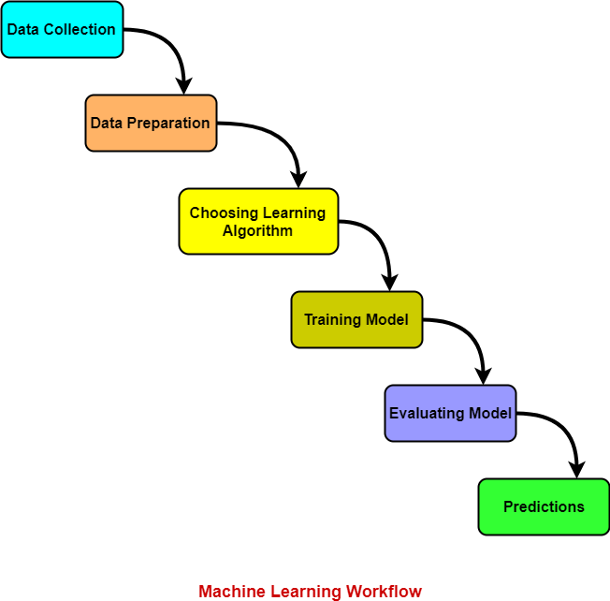

**Step 6:** Testing & Visualization

* **DATA FLOW DIAGRAM**
* **RESULT**

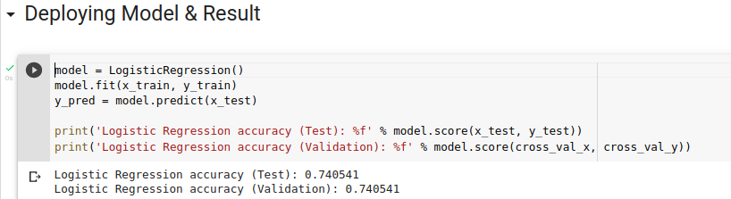

* **CONCLUSION**

The football transfer network exhibits some of the traditional characteristics of complex networks, as this experiment demonstrates, but it also disproves the small-world property. The non-small-world characteristic is unexpected given the prevalence of small-world networks, but it could mean that clubs limit their transfer activity to, for example, their domestic rivals and/or teams in the same competitive weight class.